Video Chat Room Module

Introduction
The Video Chat Room module allows administrators to create and manage virtual meeting rooms for communication, such as prayer meetings or group discussions. Members can be invited to join and interact in real-time through video conferencing.
How to Access Video Chat Room
- Login to the system using Admin credentials.
- From the dashboard, navigate to Video Chat Room.
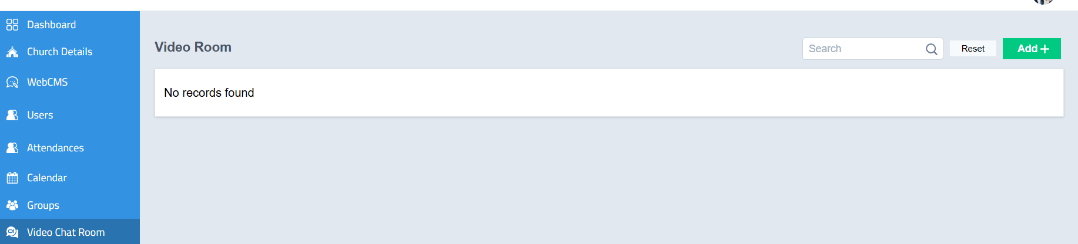

How to Create a Video Chat Room

Step-by-Step Procedure
- On the Video Chat Room page, click the Add button located at the top-right corner.
- A new form will open.
- Enter the required details:
  - Title
  - Description
- Select the Members to be invited to the room.
- Click Create.

Outcome
- A new video chat room will be created successfully.
- Invited members can join the room for communication.
Note
- Video communication is hosted on a secure cloud server, ensuring safe and reliable interaction.

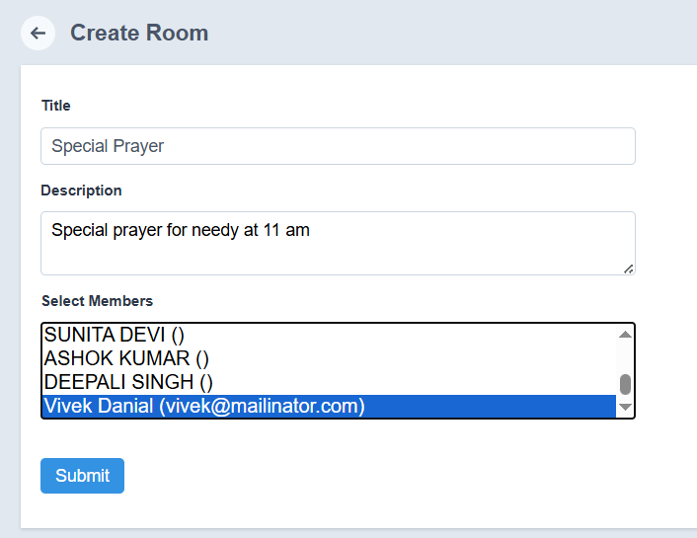

Additional Features

Edit Room
- Click the Edit button to modify:
  - Title
  - Description
  - Invited Members

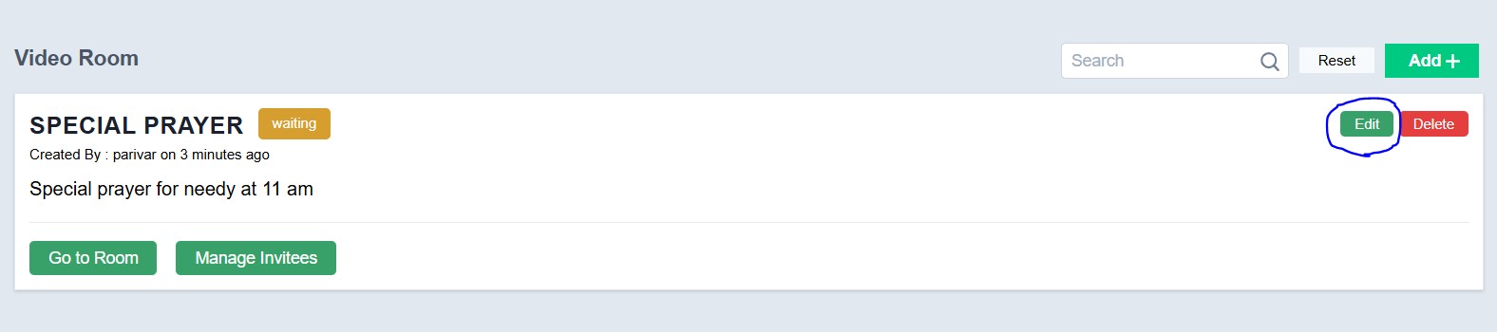

Delete Room
- Click Delete to remove the room once it is no longer required.
- Confirm the action to complete deletion.
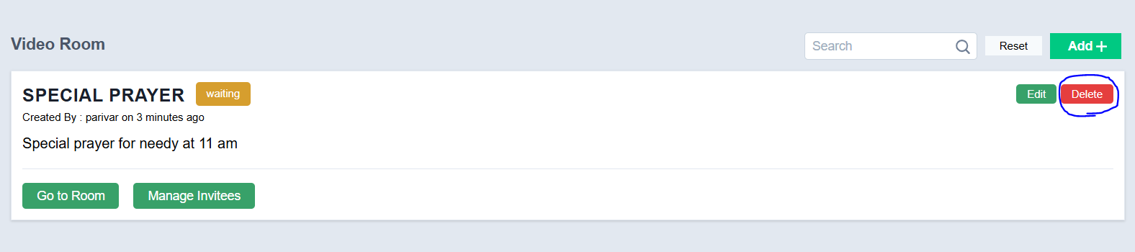

Go to Room
- Click Go to Room to enter the video chat room.
- Start video communication with invited members.

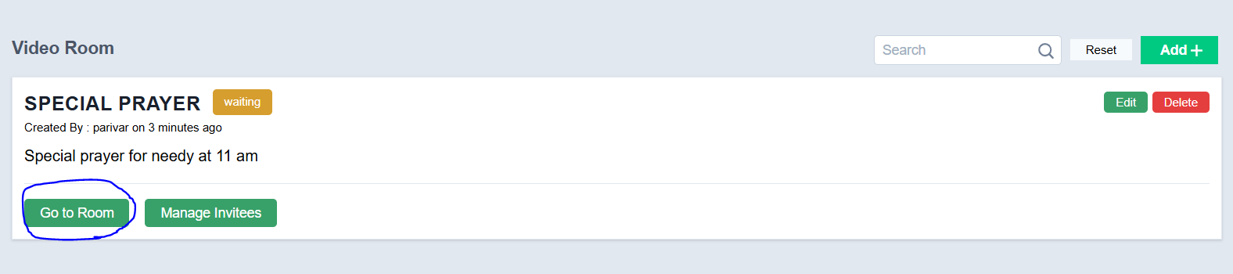

Manage Invitees
- Click Manage Invitees.
- Add or remove members from the room as required.

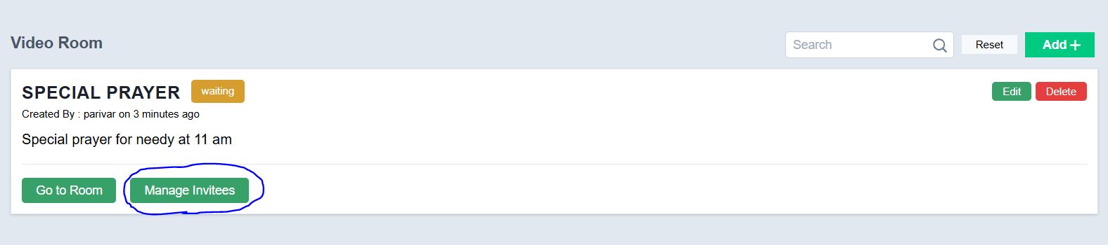

Search
- Use the Search option to quickly find specific video chat rooms.

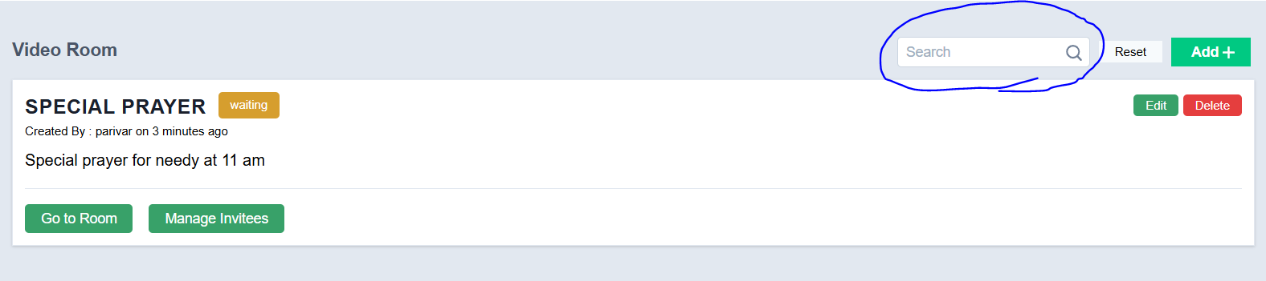

Reset
- Click Reset to clear search filters or refresh the view.
